Using ABC-USA website for online giving to American Baptist Churches USA
Step-by-step instructions

- Click the link for online giving- https://www.abc-usa.org/

- Select “GIVE ONLINE” button
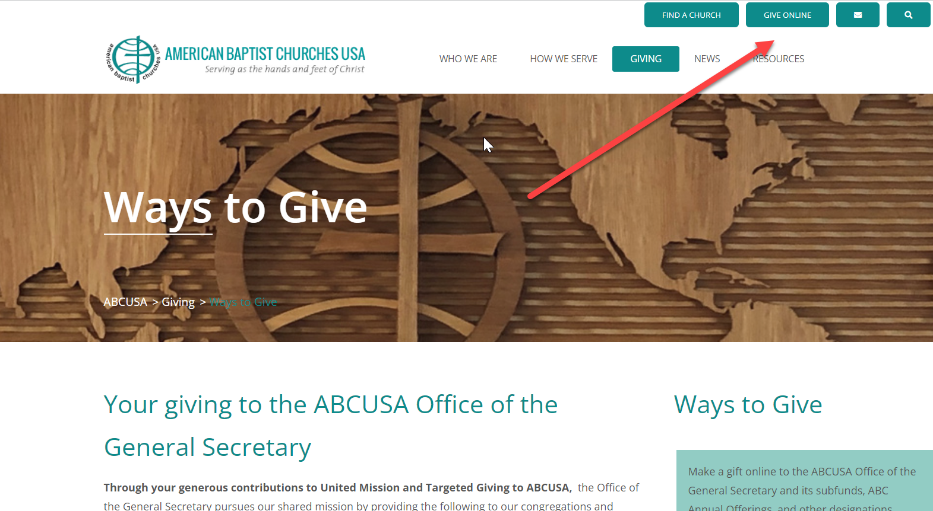

- Select Fund option:

- One-time: One time option only

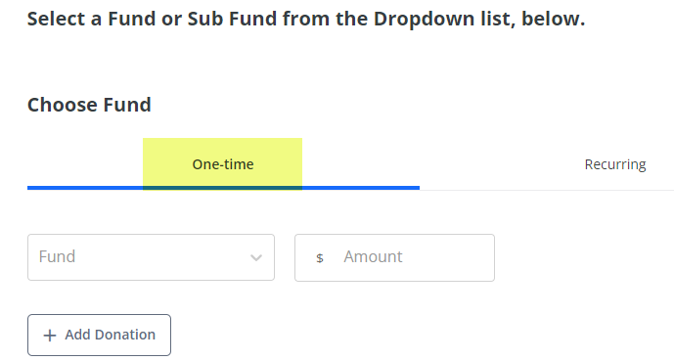

- Recurring: Option to select the amount to be taken, its frequency, and start date

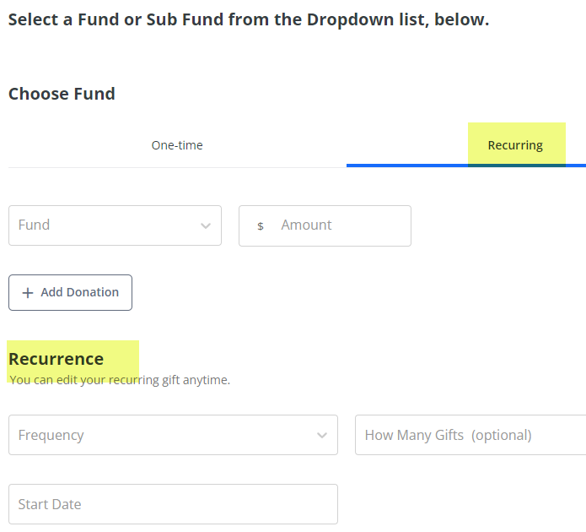

- Select the type of Fund: (5 Main Giving Funds)
Regional Offering = Cleveland Baptist Association (CBA) UMB =United Mission Basics
LG = Love Gift for American Baptist Women’s Ministry
AFC = America for Christ WMO = World Mission Offering
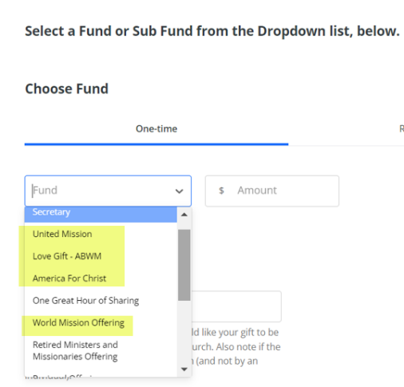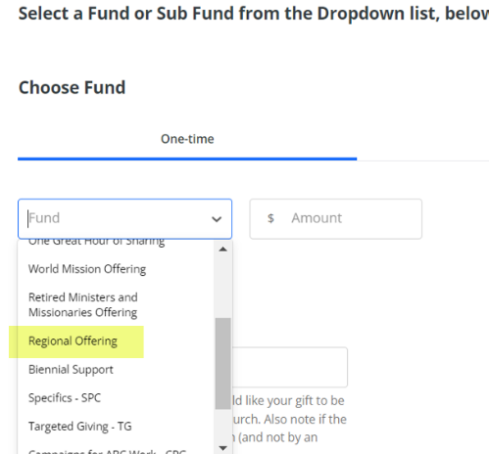

- Enter Specific Region
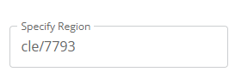
- Enter Amount to give
- Add any other donations if needed
- Enter Payment option and Billing information

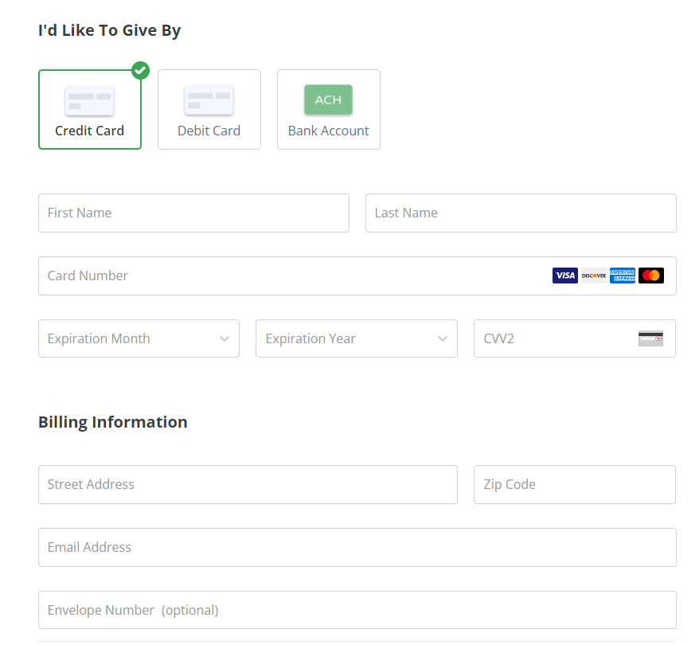

- Submit
