Using ABC-USA website for online giving to American Baptist Churches USA
https://www.abc-usa.org/
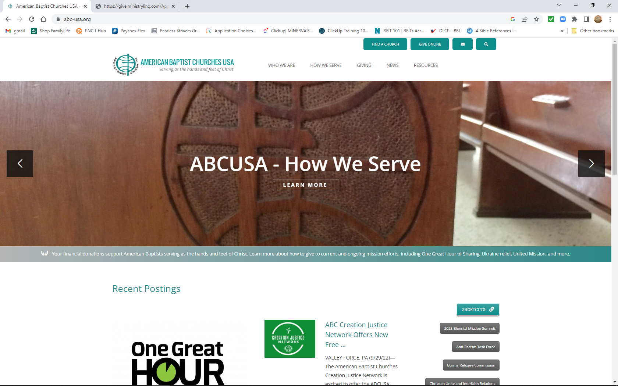

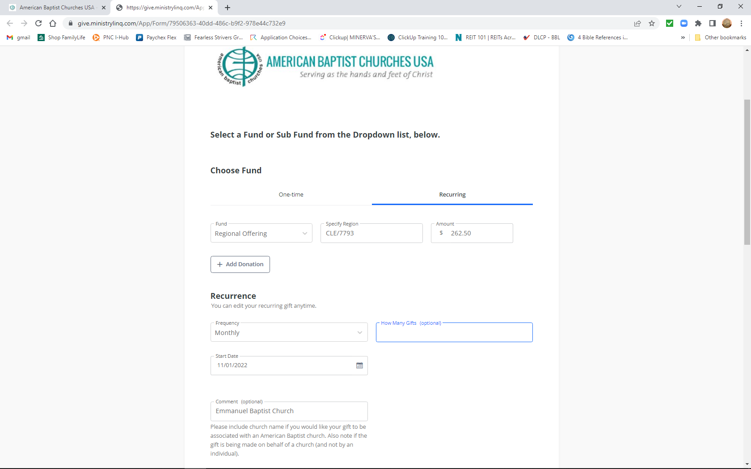
MAIN GIVING FUNDS UMB =United Mission Basics, LG = Love Gift for American Baptist Women’s Ministry, AFC = America for Christ,
WMO = World Mission Offering, Regional Offering = Cleveland Baptist Association (CBA)
