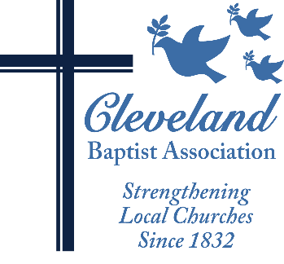
Cleveland Baptist Association
12200 Fairhill Rd. Ste C/440 Cleveland, Ohio 44120
Telephone: 216-325-7730 Website: www.cbacleveland.org
Reverend Yvonne Carter, Executive Minister

J B PRYCE MEMORIAL SCHOLARSHIP

APPLICATION PACKET

Please read carefully and follow all instructions. Applications and all attachments are due by midnight on December 31st, and can be mailed to Rev. Camille D. Brown, Scholarship Fund Administrator c/o the CBA office.
______________________________________________________________________________

The following criteria have been established by the CBA Department of Ministry to govern awards from the J B Pryce Memorial Scholarship:

- Assistance is available to CBA pastors and church ministry leaders who have registered to attend a Specialized Ministry Enrichment Training Program.
- Applicants must be members in good standing of a CBA mission-giving church and recommended by their pastor.

- The program or course for which assistance is requested must be conducted within the calendar year for which scholarship is awarded.
- The applicant must include a written description of the course or specialized training program and a copy of the registration confirmation with the scholarship application.
- There must be a planned application of the learning for ministry.

If you meet the established criteria and are interested in applying, please complete the attached application form legibly and in ink and submit the application by the above deadline.

Please have your pastor sign the Pastoral Recommendation Form and submit it directly to the CBA Office by the application deadline.

All forms should be sent c/o Rev. Camille D. Brown, Fund Administrator.

Following the review of applications by the Department of Ministry, personal interviews may be scheduled. If you have any further questions, please contact Rev. Camille D. Brown at 216-325-7730.

J B PRYCE MEMORIAL SCHOLARSHIP
APPLICATION FORM

_________________________________________________________________________________________
Applicant’s Full Name and Title (Minister, Rev., Dr., Mr. Mrs. Ms):

______________________________________________________________________ (H)___(W) ___(C)___
Preferred Mailing Address (Home, Work, Church):

_________________________________________________________________________________________
City, State, Zip:

_________________________________________________________________________________________
E-Mail Address:

_________________________________________________________________________________________
Home Phone (with area code):

_________________________________________________________________________________________
Work Phone (with area code):

__________________________________________________________________________________________
Name of Applicant’s CBA Church:

(Please check all the following that apply to you):
_____Licensed
_____Ordained
_____Other (explain) _______________________________________________________________________

________________________________________________________________________________________
Name of Program or Course:

_________________________ $_______________
Course Credit Hours/CEUs Cost of Course/Program

_____________________________________________________________________________
Name of Specialized Ministry Program

_____________________________________________________________________________
Dates of Program or Course:

Scholarship Application (Page Two)
Personal Goals and Aspirations
Please describe your goals and aspirations in pursuing this program or taking this course. Please use reverse, or a separate sheet, if more space is needed.

Current Ministry Involvement
Please describe your current ministry involvement or duties in your local church.

Current CBA Involvement/Knowledge
Are you currently involved in any CBA Boards, Committees or Volunteer Service? Please describe.

Do you participate in the CBA Annual Meetings and/or Events? Please describe.

Financial Need
Please describe how the CBA Theological Scholarship will help you manage the costs associated with this course or program.

Course/Program Description
Please attach a brief description of the course or program for which support is being requested, along with evidence of enrollment and/or a transcript of previous work in program if applicable.
S

Pastoral Recommendation
Please provide the attached recommendation form to your pastor and ask him or her to return it directly to CBA.

Thank you for your interest and your application!

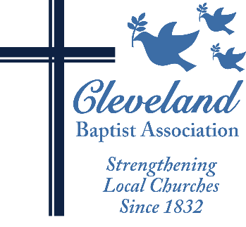
J B PRYCE MEMORIAL SCHOLARSHIP
PASTOR’S RECOMMENDATION FORM

Name of Applicant: ________________________________________________________________

Dear Pastor:

Each applicant for financial assistance from the J B PRYCE MEMORIAL Scholarship Fund must submit a Pastor’s Recommendation Form as part of the application process. Please take a few minutes and tell us about the above-named applicant.

Is the applicant an active member in good standing of your church and active in/attendee at CBA events? ______Yes ______ No

How is the applicant involved in ministry in and through your church?

How will the program or course of study for which assistance is requested enhance this person’s current ministry or potential for future ministry?

Has the church supported, or is it planning to support, the applicant with any financial assistance toward this program or course? ______Yes ______No
Please describe:

Do you recommend the applicant for a J B PRYCE MEMORIAL SCHOLARSHIP award? ______Yes ______No

Name of Pastor: (Please Print) ________________________________________________________________

Signature: ___________________________________________________Date: ________________________

The deadline for the receipt of application material and recommendations is December 31st. Thank you for taking a few minutes to complete this form in support of this applicant. After completing this form, please mail it directly to: Rev. Camille D. Brown, Theological Education Scholarship Fund Administrator, Cleveland Baptist Association, 12200 Fairhill Ave. Room C/440 Cleveland, OH 44120.

Thank You!

